Integrated courses in Mass spectrometry
L3 Analytical Chemistry UFAZ

Exercise 1

Consider the following electron impact mass spectrum of Limonene.

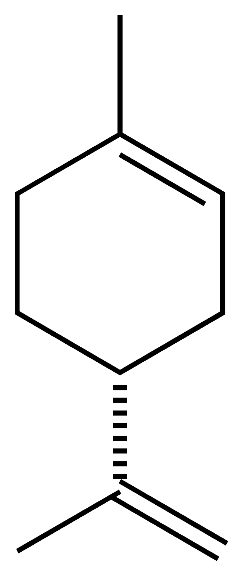

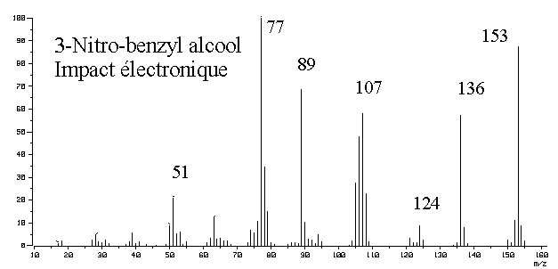
136

M^{+•}

Limonene
Electron Impact

121

93

68
41

- Explain the principle of electron impact and the way to obtain a molecular ion?
- Calculate the mass of the compound using the spectrum?

Exercise 2

Consider the following MS spectra obtained using an ESI-MS:
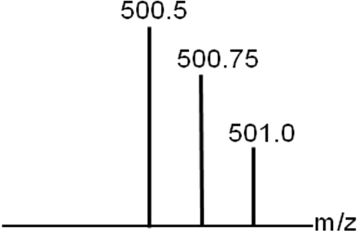
500.625
500.75

- What is the state of charge of these molecules?

- Calculate the monoisotopic mass of these molecules?

Exercise 3

Consider the following MS spectra :

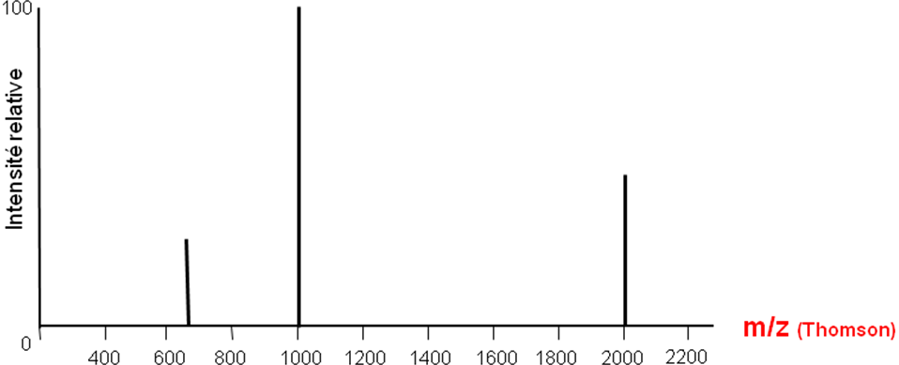

Pic 1 : m/z 667,8 Th
Pic 2 : m/z 1001,1 Th
Pic 3 : m/z 2001,1 Th
- With what source was this spectrum obtained?
- Calculate the mass of the compound.
Exercise 4

The following MS spectrum correspond to a protein analyzed with electrospray introduction (ESI) in positive mode.

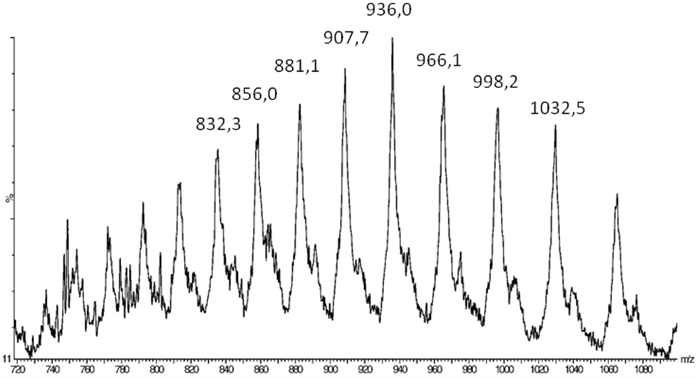

Calculate the mass of this molecule?

Exercise 5

The following spectrum correspond to cytochrome C analyzed with electrospray introduction (ESI) in positive mode 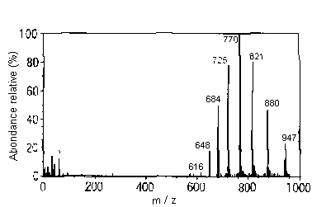
Calculate the mass of this molecule?

Exercise 6

The mass spectrum of different oligomers of native hemocyanin from Bithograea thermidron (crab category living in the depths of the ocean) was performed using an ESI-TOF.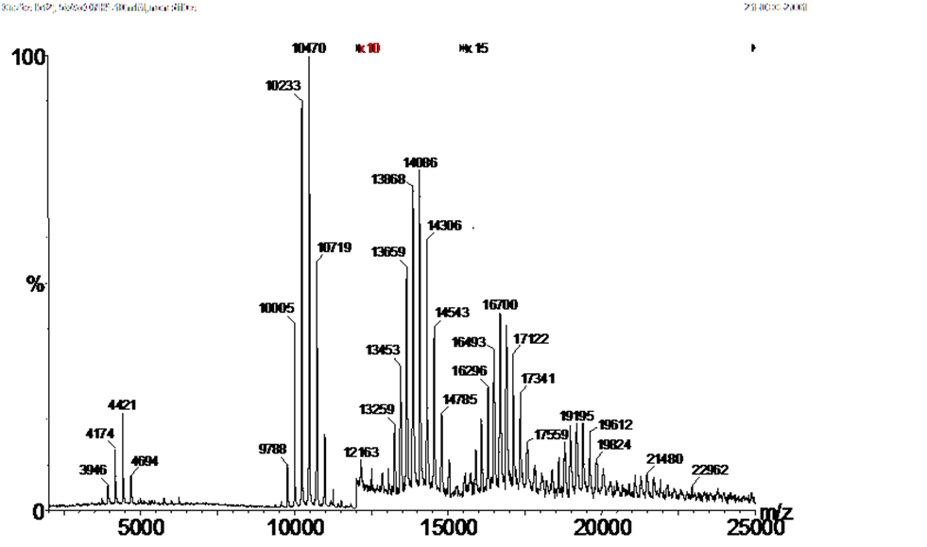
(1) Calculate the mass of each oligomer?

Note: For the calculation of the load of the third, fourth and fifth peaks, consider masses 13659 and 13868, 17122 and 17341, 19612 and 19824

(2) Knowing that the mass of a monomer is around 75000 Da, determine the number of monomers forming each compound?
(3) Why did you use an ESI-TOF device?

Exercise 7

Consider a mixture of two compounds: 1,2-ethanediol (C₂H₆O₂) and ethanethiol (C₂H₆S).
- Is it possible to detect and identify these two compounds by mass spectrometry (MS)? Explain?
Coupling of MS with gas chromatography (GC) is proposed. In this case, will it be possible to detect and identify these two compounds? Explain?
Isotopic data:
M | M+1 | M+2
¹²C 98,9% | ¹³C 1,1%
¹⁶O 99,8% | ¹⁷O ε | ¹⁸O 0,2%
³²S 95,02% | ³³S 0,75% | ³⁴S 4,21%

Exercise 8

- What is the role of the source in a mass spectrometer?

- Why should ions be in the gaseous form for mass analysis?

- Describe the principle of a source by chemical ionization?

- The following spectra (a) and (b) of 3-Nitro-Benzyl-Alcohol were made by electron impact and chemical ionization? Can you say which was realized by electronic impact and which one was realized by chemical ionization? Justify your answer

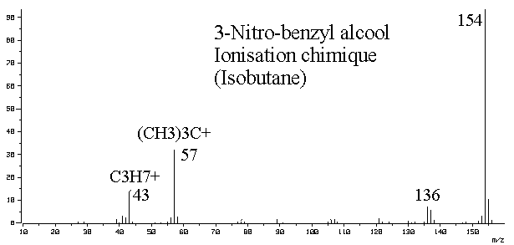
(a)
(b)

Exercise 9

Consider chlorine and bromine.

- Calculate the average mass of Cl and Br

- Model the isotopic profile of these two elements.

Isotopic data:
M | M+1 | M+2
³⁵Cl 75,8% | ³⁶Cl ε | ³⁷Cl 24,2%
⁷⁹Br 50,7% | ⁸⁰Br ε | ⁸¹Br 49,3%

Exercise 10

- Describe with a diagram the principle of a MALDI source

- What is the role of the matrix in a MALDI analysis?

- How many compounds are there in this MALDI spectrum acquired in positive mode?

2001,2
653,4

- Calculate the mass of the compound(s)?

