Epreuve de Notion d'échelle dans les méthodes de séparation
Master 2 Sciences Analytiques
(M. François)
(1 heure)

Remarque : Les documents de cours et la calculatrice sont autorisés lors de cette épreuve.

ELECTROPHORESE CAPILLAIRE : NOUVEL OUTIL DANS L’ANALYSE TOXICOLOGIQUE.
SEPARATION DE DROGUES PAR CHROMATOGRAPHIE ELECTROCINETIQUE MICELLAIRE

Ce sujet est issu de la publication. Tagliaro et al. Forensic Sci. Int. 70 (1995) 93-104

MEKC of compounds of forensic interest
MEKC is suitable for obtaining highly efficient separations of drugs and other compounds of forensic interest. In our experience, using a slightly different buffer system, we succeeded in separating with excellent resolution as many as 20 compounds, namely caffeine, morphine, pentobarbital, barbital, narceine, monoacetylmorphine (tentative), codeine, nalorphine, lidocaine, procaine, heroin, flunitrazepam, acetylcodeine, tebaine, papaverine, amphetamine, narcotine, cocaine, diazepam and tetracaine, which migrated in this order, with a total run time of 40 min (Fig. 1 and Table 1). In order to improve as much as possible the resolving power of the system, the MEKC separation was carried out in a 50 µm inner diameter capillary, which because of better heat dissipation, typically allows higher efficiency. Injected volumes were 5 nL. Other conditions are detailed in the legend of Fig. 1. The sensitivity (detection at 200 nm) was different for the various compounds; however, calculated for morphine, it was about 3 µg/mL (signal-to-noise ratio, 5), whereas for a late eluting peak, such as cocaine, it was about 12 µg/ml.

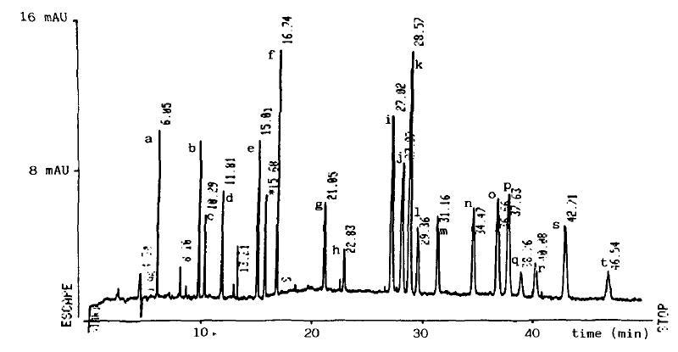

Fig. 1. MEKC separation of a mixture of 20 therapeutic and illicit drugs, congeners and naturally occurring impurities (concentration range: 10-40 µg/ml for each compound). Conditions: bare silica capillary (60 cm total length, 40 cm to the detector) with id. of 50 µm. The MEKC buffer was composed of 0.025 M borate, pH 9.2, containing 20% methanol and 0.1 M SDS. The potential was 20 kV. Detection by UV absorbance at 200 nm wavelength. List of separated compounds: caffeine (a), morphine (b), pentobarbital (c), barbital (d), narceine (e), monoacetylmorphine (tentative) (f), codeine (g), nalorphine (h), lidocaine (i), procaine (i), heroin (k), flunitrazepam (I), acetylcodeine (m), tebaine (n), papaverine (o), amphetamine (p), narcotine (q), cocaine (r) and diazepam (s).

 | Compounds | t_{R}
t_{o} | Flux électroosmotique | 5,32
a | Caffeine | 6,05
b | Morphine | 9,70
c | Pentobarbital | 10,29
d | Barbital | 11,81
e | Narceine | 15,01
g | Codeine | 21,05
i | Lidocaine | 27,02
j | Procaine | 27,97
k | Heroin | 28,57
o | Papaverine | 36,66
p | Amphetamine | 37,63
r | Cocaine | 40,08
s | Diazepam | 42,71
t* ou t_{mc} | Temps Micelles libres | 46,54

Table 1 : MEKC of drugs and impurities of illicit heroin

Questions :

- Décrire brièvement le principe de la MEKC.

- Calculer le champ électrique appliqué dans les conditions données (en V.cm⁻¹).

- Calculer la mobilité électroosmotique. Calculer la mobilité électrophorétique des micelles libres (en cm².V⁻¹.s⁻¹)

- Calculer le facteur de rétention k’ et la mobilité électrophorétique de la morphine, de l’héroine et de la codéine. (en cm².V⁻¹.s⁻¹)

- A quelle famille (cation, neutre ou anion) appartiennent ces trois composés à pH 9,2 ? Justifier ?

- Justifier l’ordre de sortie de ces trois composés.

- D’après les auteurs, pourquoi utilise-t-on un capillaire de 50 µm de diamètre interne ?

ANNEXE

Formule chimique et pKa

Morphine pKa = 7,9

Codéine pKa = 7,7

Héroine pKa = 7,8

Indice de Rekker

– OH : - 0,343
– OCH₃ : - 0,152
- O2CH₃ : - 0,063

